**Raspberry Pi Tutorial  
URL:** <https://wiki.dfrobot.com/Gravity__I2C_ADS1115_16-Bit_ADC_Module_Arduino_&_Raspberry_Pi_Compatible__SKU__DFR0553>

This tutorial will demonstrate how to use the ADC module to read 4 channels analog signals with Raspberry Pi. Please switch the I2C address to 0x48.

**Requirements**

* **Hardware**
  + [Raspberry Pi 3 Model B](https://www.dfrobot.com/product-1419.html) (or similar) x 1
  + I2C ADS1115 16-bit ADC Module x 1
  + Analog Sensors(sound, voltage, temperature, ambient light, etc.) x4
  + Gravity 4pin Cable (or several DuPont cables) x1
* **Software**
  + [DFRobot_ADS1115 Raspberry Driver](https://github.com/DFRobot/DFRobot_ADS1115/tree/master/RaspberryPi)
  + [RASPBIAN](https://www.raspberrypi.org/downloads/raspbian)

**Connection Diagram**

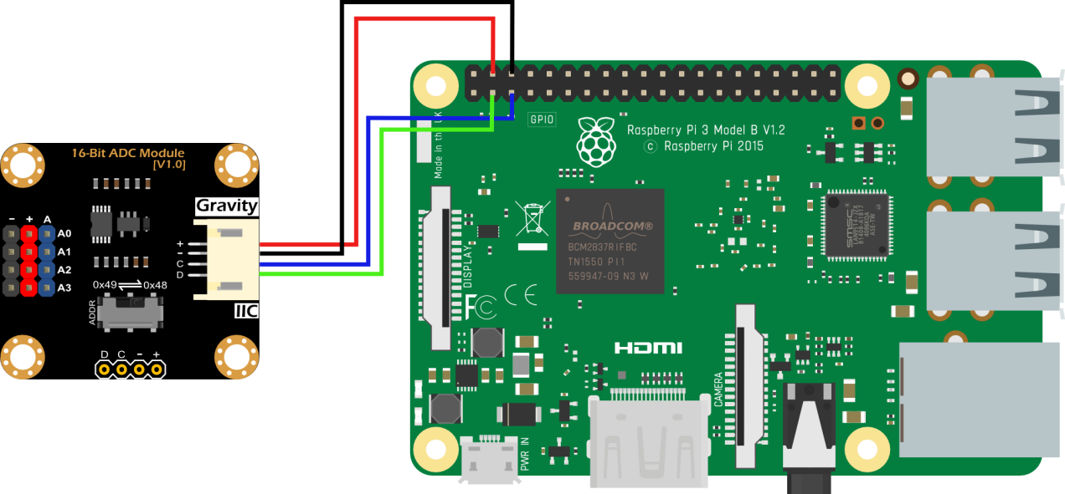

**Install Driver**

* 1.Open the Raspberry Pi I2C interface. If it is already open, skip this step.

Open Terminal, type the following command, and press Enter:

sudo raspi-config

Then use the up and down keys to select “5 Interfacing Options”, press Enter, select “P5 I2C” and press Enter to confirm “YES”. Restart the Raspberry Pi.

* 2. Install the Python related libraries and git, then Raspberry Pi requires networking. If it is already installed, skip this step.

In the terminal, type in the following commands in order, and press Enter:

sudo apt-get update

sudo apt-get install build-essential python-dev python-smbus git

* 3. Download the driver and run. In the terminal, type in the following commands in order, and press Enter.

git clone https://github.com/DFRobot/DFRobot_ADS1115.git

cd DFRobot_ADS1115/RaspberryPi/Python

sudo python DFRobot_ADS1115.py

**Run the Sample Code**

* In the terminal, type the following commands in order, and press Enter:

cd ~/DFRobot_ADS1115/RaspberryPi/Python/ADS1115_ReadVoltage

sudo python ADS1115_ReadVoltage.py

**Expected Results**

